Augmentative Communication Supports | Name | What is it? | How do I describe it in the IEP?
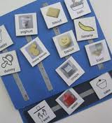 | Picture Exchange Communication System (PECS) | Picture-based communication protocol | Describe reinforcers, number of pictures, size of pictures, what the students is doing and not able to yet master.  Ex: Student is able to hand a picture to get a desired item but is not able to discriminate two pictures.
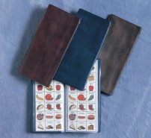 | Topic notebook/communication book | Picture-based communication notebook, communication book, or wallet. Used as a communication repair strategy | Describe what the system looks like (size, layout, etc), level of proficiency, environments where book is used, etc.
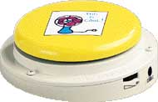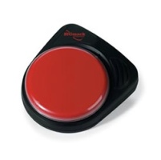 | Big Mack | Single message voice output communication device | Describe how it is being used and in which activities it is being used and level of proficiency.  Ex: Student uses device to participate in circle time activities 40% of time.
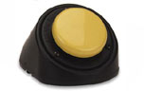 | Little Mack | Single message voice output communication device | Describe how it is being used and in which activities it is being used and level of proficiency.  Ex: Student uses device to ask for attention 25% of time.
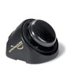 | One Step | Single message voice output communication device | Describe how it is being used, in which activities it is being used, and level of proficiency.  Ex: Student uses device to request a drink at mealtime in 3 out of 5 trials.
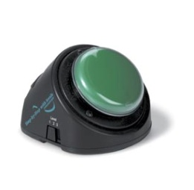 | Step by Step | Mulitiple level voice output communication device with looping | Describe how it is being used,in which activities it is being used, and level of proficiency.  Ex: Student uses device to relay a 3-part knock-knock joke with 50% proficiency across 3 settings.
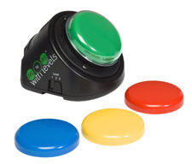 | Little Step by Step with Levels | Single activation site, multiple level voice output communication device with looping | Describe how it is being used,  in which activities it is being used, and level of proficiency.  Ex: Student uses device to supply the repeated line in a story in 8/10 trials.
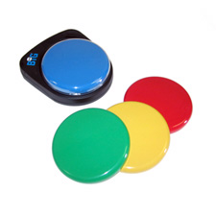 | Big Step by Step | Single activation site communication device with large activation surface and ability to record multiple sequential messages | Describe how it is used, in which activities it is used, and level of proficiency.  Ex: Student uses device to sequence a 3 step activity with 75% accuracy.
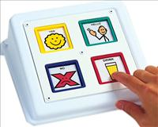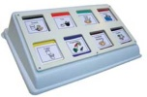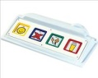 | Cheap Talk 4, 8, 8 with levels, or inline | Four or eight message communication device (with or without levels) and overlays | Describe the number of pictures used on a screen, how many levels (overlays), and types of activities in which it is being utilized.
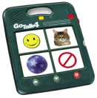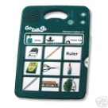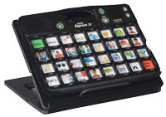 | Go Talk 4+, 9+, 20+, Express | Four, nine, twenty, or thirty-two message communication device with levels and overlays | Describe the number of pictures used on a screen, how many levels (overlays), and types of activities in which it is being utilized.
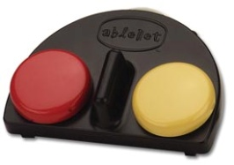 | iTalk2 | Two message voice output communication device | Tell how the student is using it  Ex: Student uses a 2 button switch to indicate preferred vs. non-preferred item.
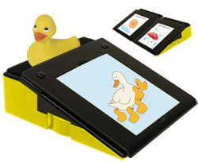 | Partner Plus | Single message communication device | Describe how it is being used, in which activities it is being used, and level of proficiency.  Ex: Student uses device 3x per week to lead the Pledge of Allegiance.
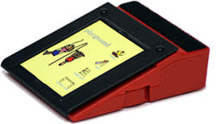 | Partner Plus/Stepper | Single panel augmentative communication device with a stepping feature that enables the user to record a sequence of messages | Describe how it is being used, in which activities it is being used, and level of proficiency.  Ex: Student uses device to participate in music class.
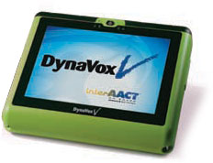 | Dynavox V | Dynamic display communication device with computer access (describe method of activation) | Describe the number of buttons, number of screens, and access method (direct selection, touch enter or touch exit, etc).  Ex: Student accesses a 12 button screen during activities: circle time, lunch time, math, reading, social interactions, etc.
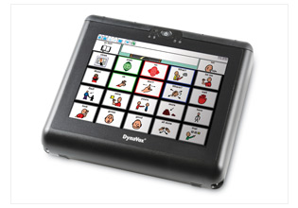 | Dynavox V+ | Dynamic display communication device with computer access (describe method of activation) | Describe the number of buttons, number of screens, and access method (direct selection, touch enter or touch exit, etc).  Ex: Student accesses a 12 button screen during activities: circle time, lunch time, math, reading, social interactions, etc.
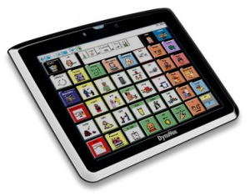 | Maestro | Dynamic display communication device with computer access (describe method of activation) | Describe the number of buttons, number of screens, and access method (direct selection, touch enter or touch exit, etc).  Ex: Student accesses a 12 button screen during activities: circle time, lunch time, math, reading, social interactions, etc.
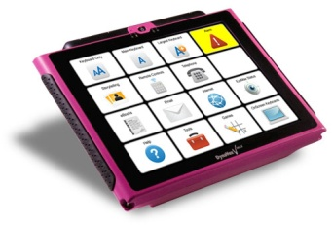 | Dynavox VMax | Dynamic display communication device with computer access (describe method of activation) | Describe the number of buttons, number of screens, and access method (direct selection, touch enter or touch exit, etc).  Ex: Student accesses a 12 button screen during activities: circle time, lunch time, math, reading, social interactions, etc.
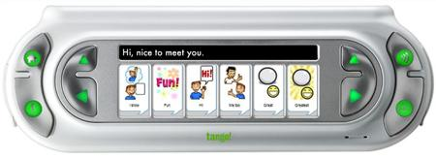 | Tango | Dynamic display communication device with computer access (describe method of activation) | Describe the number of buttons, number of screens, and access method (direct selection, touch enter or touch exit, etc).  Ex: Student accesses a 12 button screen during activities: circle time, lunch time, math, reading, social interactions, etc.
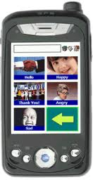 | Cyrano | Dynamic display communication device with computer access (describe method of activation) | Describe the number of buttons, number of screens, and access method (direct selection, touch enter or touch exit, etc).  Ex: Student accesses a 12 button screen during activities: circle time, lunch time, math, reading, social interactions, etc.
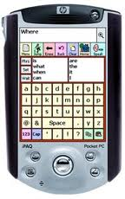 | Say It Sam | Dynamic display communication device with computer access (describe method of activation) | Describe the number of buttons, number of screens, and access method (direct selection, touch enter or touch exit, etc).  Ex: Student accesses a 12 button screen during activities: circle time, lunch time, math, reading, social interactions, etc.
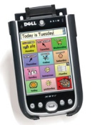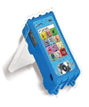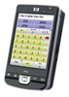 | Chat PC, Chat Silk, Chat PC4 | Dynamic display communication device with computer access (describe method of activation) | Describe the number of buttons, number of screens, and access method (direct selection, touch enter or touch exit, etc).  Ex: Student accesses a 12 button screen during activities: circle time, lunch time, math, reading, social interactions, etc.
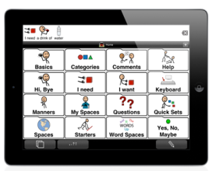 | Ipad | Tablet with augmentative communication app | Describe the number of buttons, number of screens, and how well the student navigates between screens.  Ex: Student accesses a 12 button screen during activities: circle time, lunch time, math, reading, social interactions, etc.
 | Ipod | Hand-held portable media player with augmentative communication app | Describe the number of buttons, number of screens, and how well the student navigates between screens.  Ex: Student accesses a 12 button screen during activities: circle time, lunch time, math, reading, social interactions, etc.
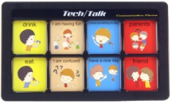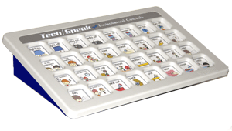 | TechTalk 8, 32 | Multiple level static display communication device with picture | Describe the number of pictures used on a screen, how many levels (overlays), and types of activities in which it is being utilized.
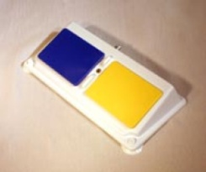 | Twin Talk | Two button communication device | Tell how the student is using it  Ex: Student uses a 2 button switch to say “hi” and “bye” whenever anyone enters or exits the classroom.

Curricular/Modification and Writing Supports | Name | What is it? | How do I describe it in the IEP?
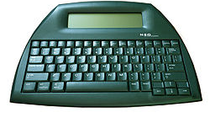 | Alphasmart | Portable word processor with word prediction | Describe when and how the student uses it and level of proficiency. Indicate features that are utilized (word prediction, spell check, etc).
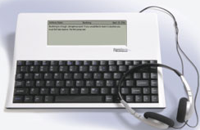 | Fusion | Portable word processor with auditory output | Describe when and how the student uses it and level of proficiency. Indicate features that are utilized (word prediction, spell check, etc).
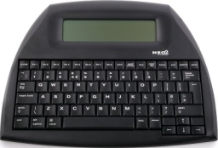 | Neo | Portable word processor with auditory output | Describe when and how the student uses it and level of proficiency. Indicate features that are utilized (word prediction, spell check, etc).
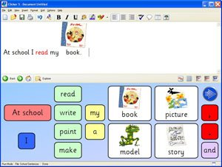 | Clicker 5 | Curricular modification software which allows lessons to be computerized for students | Describe when and how the student uses it and level of proficiency.
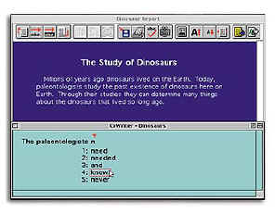 | Co:Writer | Word predication software with auditory output | Describe when and how the student uses it and level of proficiency. Indicate information such as number of guesses, method to select guesses (mouse, number, etc) and proficiency level.
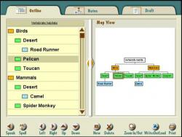 | Draft Builder | Software which allows students to create drafts from brainstorming and outlining to writing the first draft | Describe how the writing scaffolds have been set up to support student.
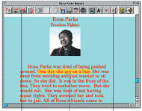 | WriteOut:Loud | Auditory word processing software | Describe when and how the student uses it and level of proficiency. Indicate information such as utilized features, size of font, voice, reading sentence or paragraph, etc.
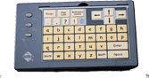 | Intellikeys | Alternative keyboard access with interchangeable overlays | Name overlay, how student activates keyboard (direct selection, switch, keyguard). Describe activities in which the student uses the keyboard and software that is used (Word, Write Out:Loud, etc).
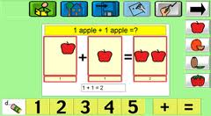 | Intellimathics | Software which allows the math curriculum to be modified for students to solve math equations on the computer | Describe the template being used and any changes that have been made to the template. Describe how well the students use the software.
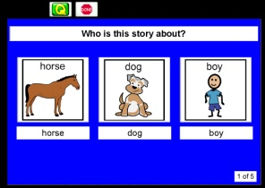 | Classroom Suite | Curricular modification software which allows lessons to be computerized for students | Describe activities in which the software is being used and how well the student uses it.
 | Ipad | Tablet with apps to support access to curriculum and written communicaiton | Describe when and how the student uses it and level of proficiency. Indicate features that are utilized.  Ex: Student completes essays and research papers as homework.
 | Ipod | Hand-held portable media player with apps to support access to curriculum and written communicaiton | Describe when and how the student uses it and level of proficiency. Indicate features that are utilized.  Ex: Student uses device to take notes in class.
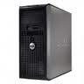 | Computer | Access to computer for word processing (describe method of access) | Describe when and how the student uses it and level of proficiency. Indicate features that are utilized.  Ex: Student uses device to take notes in class.
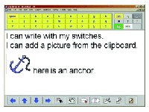 | Intellitalk | Auditory word processing software | Describe when and how the student uses it and level of proficiency. Indicate information such as utilized features, size of font, voice, reading sentence or paragraph, etc.
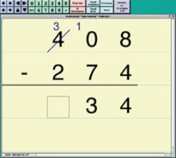 | MathPad | Software which allows students to complete math facts on the computer | Describe level or activity used and how the student accesses the software (keyboard, switch, etc).
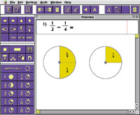 | MathPad+ | Software which allows students to complete math facts on the computer | Describe level or activity used and how the student accesses the software (keyboard, switch, etc).
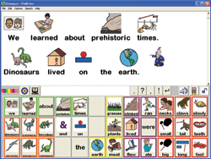 | Pixwriter | Picture based auditory written expression | Describe templates (number of pictures, words and/or words, etc) activities, and method of access (keyboard, mouse, switch).
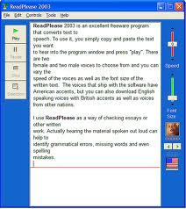 | Readplease | Online auditory output software | Describe voice, rate of speech, activities in which software is used, size of font, etc.
 | Cause and Effect software | Cause and effect software | Describe the software used, how the student accesses the software, and the purpose in using cause and effect software.
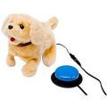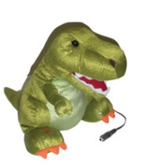 | Toy | Switch adapted toy | Describe the toy, how the student accesses it, and which skill is being developed through the use of the toy.
 | First Words software | Early vocabulary software | Describe how the student activates the software and the proficiency with which they make a correct choice
 | First Verbs software | Early vocabulary software emphasizing the acquisition of verbs | Describe how the student activates the software and the proficiency with which they make a correct choice.

Access Supports | Name | What is it? | How do I describe it in the IEP?
 | Intellikeys | Alternative keyboard access with interchangeable overlays | Name overlay and how the student activates keyboard (direct selection, switch, keyguard, part of body student uses to activate). Describe where the keyboard is positioned. Ex: Student uses single thumb activation with a keyguard to select letters when the keyboard is placed slightly to the right of midline.
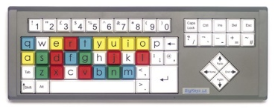 | Big Keys keyboard | Large key, alternative format keyboard-qwerty (regular) or ABC layout | Describe where the keyboard is positioned. Ex: Student uses single thumb activation with a keyguard to select letters when the keyboard is placed slightly to the right of midline.
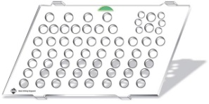 | Keyguard | Keyguard | Describe the device with which the keyguard is used and how the student accesses the device.  Ex: Student activates a standard keyboard with a keyguard using the right index finger to complete written compositions.
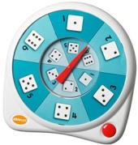 | All-Turn-It | Spinner which provides switch access for any game or activity | Describe the activity, type of switch used to activate the device, and placement of switch.
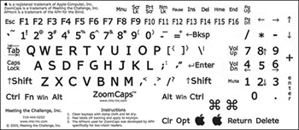 | Zoomcaps | Keyboard stickers (to enlarge letters on a standard keyboard | Describe color combination, device the stickers are on, and which of the stickers are used.
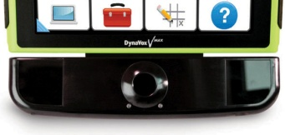 | Eye Max | Eye control alternative activation device for dynamic display communication device users | Describe the position of the device (how far from the eyes and location of device in relation to the student), size of pictures the student is successful in using, number of pictures on the screen, proficiency, and activities in which the device is being used.
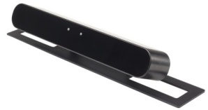 | Eye Tech | Eye control alterative activation device for use with a computer | Describe the position of the device (how far from the eyes and location of device in relation to the student), size of pictures/letters/icons the student is successful in using, number of pictures/letters/icons on the screen, proficiency, activities in which the device is being used, and types of software the device is activating.
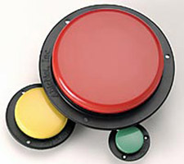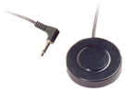 | Switches | Switches | Describe size, type of switch, location of switch in relation to the student, body part used to activate, and proficiency.
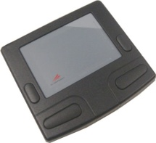 | Glidepoint/ Touchpad | Touchpad | Describe location of touchpad, body part used to activate, speed of mouse/cursor, size of mouse/cursor, and size of glidepoint/touchpad.
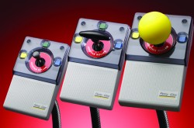 | Joystick | Joystick | Describe location of joystick, body part used to activate, speed of mouse/cursor, size of mouse/cursor, size of joystick, type of handle (t-bar, ball, etc), and whether keyguard is used on joystick.
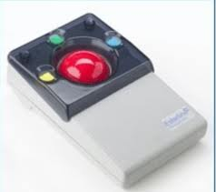 | Trackball | Trackball | Describe location of trackball, body part used to activate, speed of mouse/cursor, size of mouse/cursor, size of trackball or any need for additional resistance.
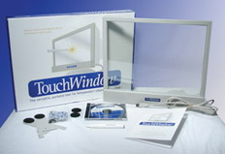 | Touchwindow | Alternative access using touch to activate the computer | Describe the activities the student is able to complete using the touchwindow and how proficient the student is at using the touchwindow.
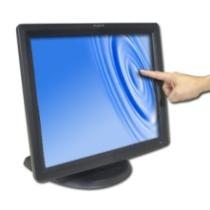 | Touchmonitor | Alternative access using touch to activate the computer | Describe the activities the student is able to complete using the touchmonitor and how proficient the student is at using the touchmonitor.
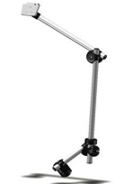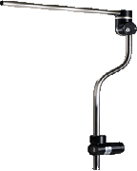 | Mounts of all types; floor mount, table mount, wheelchair | Mount | Describe how the mount is positioned to hold the device or switch (how far from student, where is it secured and where is the device/switch placed in relation to the body). Describe type of mount (floor, table, or wheelchair).
This document is to be used as a guide or reference only.

