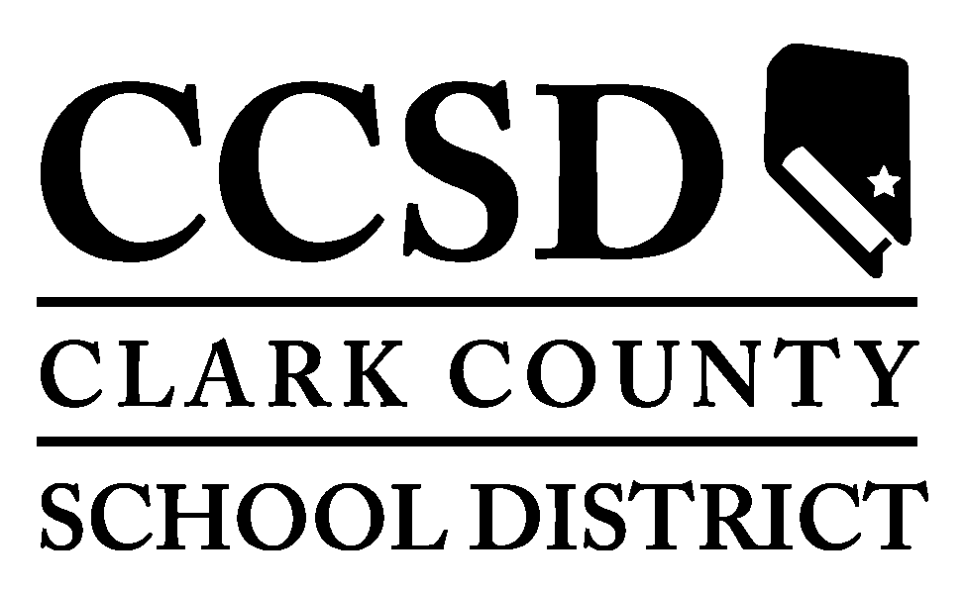

ADVERTISEMENT FOR BIDS

Pursuant NRS 338.1385, bids will be received at the Clark County School Contract, Procurement and Compliance, 1180 Military Tribute Place, Henderson, NV 89074 until, Tuesday, June 17, 2025 at 1:00 pm, through the E-Builder bidding module and read aloud publicly for the furnishing of all labor and materials to perform the Work in conjunction with the construction of:

Coronado High School
Turf Sports Fields & Xeriscape
MPID 0017972, PWP#CL-2025-309

The scope-of-work includes design services for the demolition of sod soccer, baseball, and softball sports fields and replace with synthetic turf system. In addition, xeriscape system installation on grounds surrounding sports fields that includes concrete mow curbs, ADA access, and field equipment storage pad in support of Southeast Career Technical Academy – Turf Sports Fields and Xeriscape.

Prequalified Bidders shall have a Nevada Contractor's License with the Classification of A.

The construction budget for the project is: $8,000,000.00

The Owner’s representative is: James “Buck” Maack, Project Manager, and may be reached at 702-799-8710 x 5305.

The A/E representative is: Wayne T. Salom with JW Zunino & Associates, LLC, and may be reached at 702-253-9390.

Bid documents will be available online via our cloud-based site "Bluebeam" beginning Thursday, May 15, 2025, Pre-Qualified Prime Bidders will need to email Carolina Salazar at salazc3@nv.ccsd.net to request the invitation for the digital bid documents through CCSD’s Bluebeam document viewer tool with instruction on how to view and print the Bid documents.

Bid documents will also be available 8 a.m. to 5 p.m., Monday-Friday, from RGS ReproGraphics Solutions, 6645 S. Eastern Avenue, Suite 101, Las Vegas, NV 89119, (702) 798-2055, beginning Thursday, May 15, 2025, at the requestor’s expense. Please contact RGS in advance to request copies.

Contractors Pre-Qualified pursuant NRS 338.1379 intending to bid this project must attend the mandatory pre-bid conference to be on Friday, May 23, 2025, and start promptly at 9:00 am at 1001 Coronado Center Dr., Henderson, NV, 89052. Late arrivals may not be eligible to bid as a Prime Contractor. Bidders must provide their most current letter of pre-qualification issued by the Clark County School District and all information listed in Part 5 of Document 00 21 13 – Instructions to Bidders.

The Clark County School District is an equal opportunity employer and will not knowingly discriminate in any area of employment, and invites all businesses to include women-owned, minority-owned, and disadvantaged business enterprise companies to participate in our bidding process.

Dates of Publications: Wednesday, May 14, 2025 and Sunday, May 18, 2025

By order of the
Board of School Trustees
Clark County School District

